**Task 1**

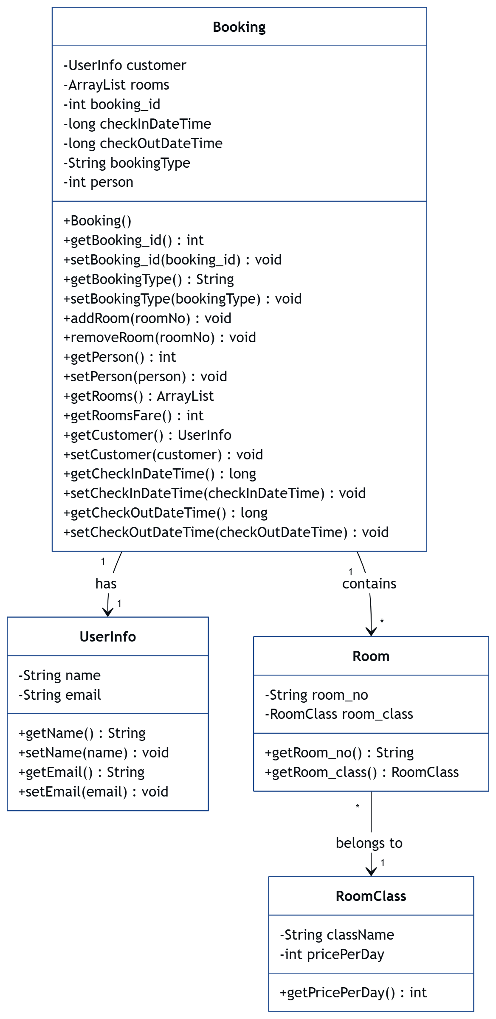

**Task 2**

package I3.Classes;

import java.util.ArrayList;

/**

* Represents additional food orders made during a customer's stay.

* Each ExtraOrders object belongs to a customer booking.

*/

public class ExtraOrders {

private ArrayList<Food> foods; // Holds list of Food items

private int orderId;

/**

* Constructor initializes with an empty food list.

*/

public ExtraOrders() {

this.foods = new ArrayList<>();

this.orderId = -1;

}

public ArrayList<Food> getFoods() {

return foods;

}

public void setFoods(ArrayList<Food> foods) {

this.foods = foods;

}

public int getOrderId() {

return orderId;

}

public void setOrderId(int orderId) {

this.orderId = orderId;

}

/**

* Adds a food item to the order.

*/

public void addFood(Food food) {

this.foods.add(food);

}

/**

* Removes a food item by name.

* @param foodName name of food item to remove

*/

public void removeFood(String foodName) {

foods.removeIf(food -> food.getFoodName().equals(foodName)); // Cleaner removal

}

/**

* Calculates total cost of the food order.

*/

public int getTotalCost() {

return foods.stream()

.mapToInt(Food::getPrice)

.sum(); // Stream used for better readability

}

}  
  
package I3.Classes;

/**

* Represents a food item in the system.

* Each food item has a name and a price.

*/

public class Food {

private String foodName; // Name of the food item

private int price; // Price of the food item

/**

* Constructor initializes food item with a name and price.

* @param foodName Name of the food item

* @param price Price of the food item

*/

public Food(String foodName, int price) {

this.foodName = foodName;

this.price = price;

}

public String getFoodName() {

return foodName;

}

public void setFoodName(String foodName) {

this.foodName = foodName;

}

public int getPrice() {

return price;

}

public void setPrice(int price) {

this.price = price;

}

/**

* Returns a string representation of the food item.

* @return Formatted string of food details

*/

@Override

public String toString() {

return "Food{" +

"foodName='" + foodName + '\'' +

", price=" + price +

'}';

}

}